Posted 07/19/2012 at 2:02 pm by JAV

Town Hall Building Committee

DRAFT Agenda
Town Hall Meeting Room
Tuesday July 24, 2012
7:00 PM

- Approve minutes

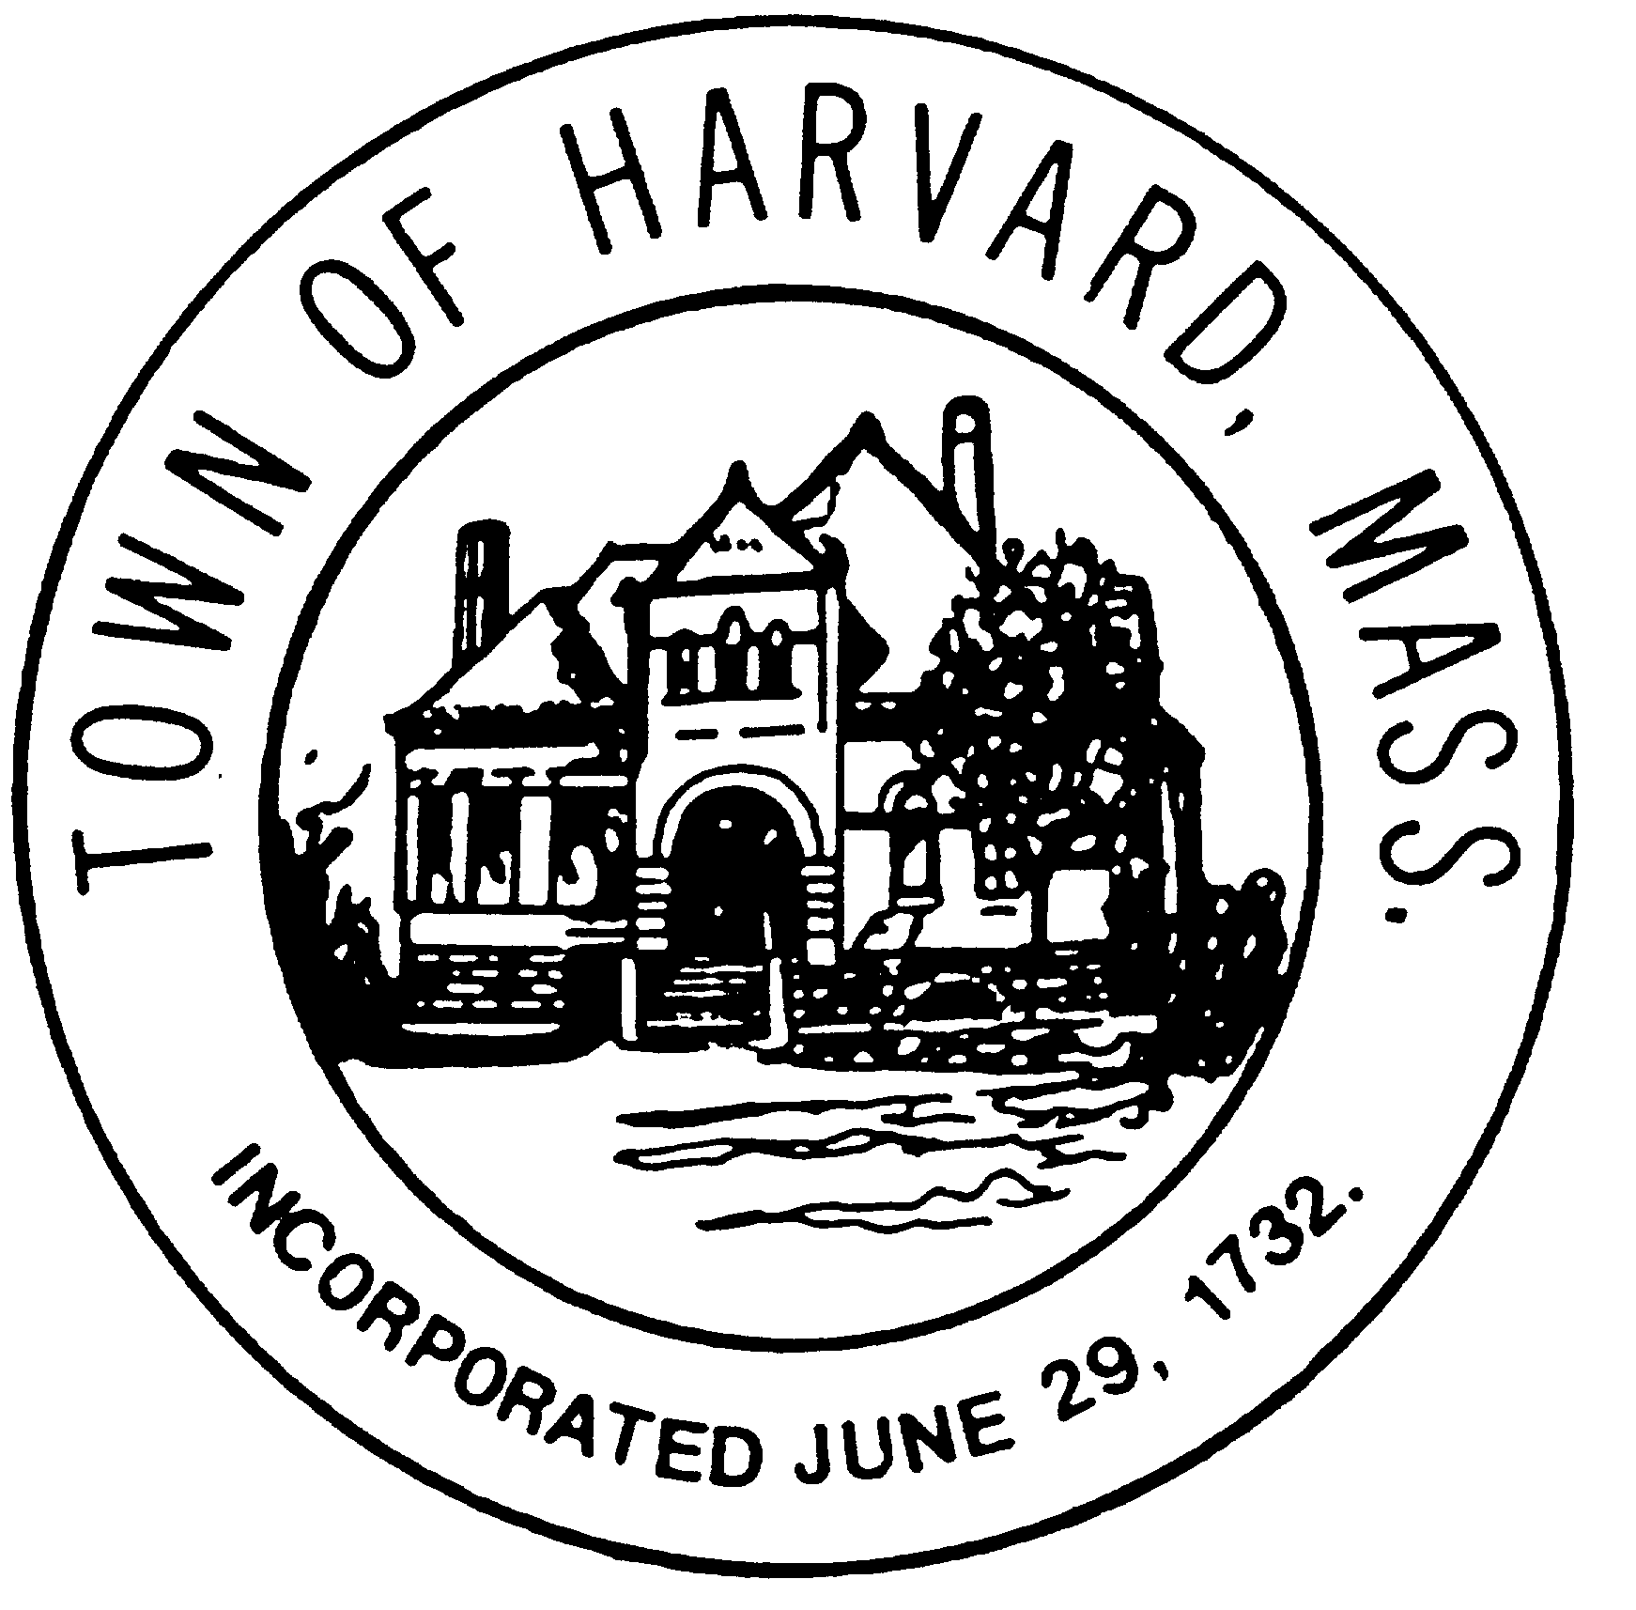
- Approve invoices

- LLB DSB evaluation

- Discuss DTI and LLB agreements and negotiation terms

- Agenda and date for next meeting(s)

- New business

